Measuring ESG Success with Metrics

Lack of Metrics
A lack of ESG metrics is a challenge both for ESG businesses and investors. Reasons for this problem are manifold:
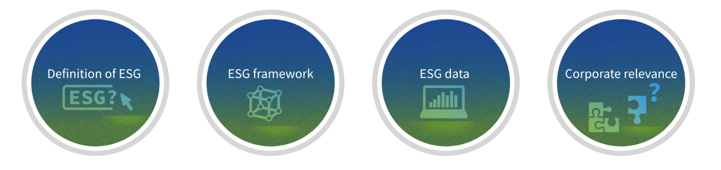
- Definition of ESG. There is no standard definition of what an ESG product or fund is, and different providers use different criteria and methodologies to measure and rate ESG performance.
- ESG Framework. There is an oversupply of tools and frameworks for ESG measurement and reporting, which can create confusion and inconsistency among users and stakeholders.
- ESG Data. There is a gap between the availability and quality of ESG data, especially for social and governance aspects, which are often more qualitative and subjective than environmental aspects.
- Corporate Relevance. There is a lack of alignment and integration between ESG metrics and the organization's strategy, values, and goals, which can reduce the relevance and impact of ESG initiatives.
Solving the Lack of Metrics
To address this lack of ESG metrics, some possible solutions are:
- Adopting a common set of standards and principles for ESG measurement and reporting, such as the ones proposed by the International Sustainability Standards Board, governed by IFRS. They are becoming the Standard of Standards, aligning with the major regulations around the world. For instance, in 2024, they will absorb the TCFD monitoring responsibilities.
- Using a combination of quantitative and qualitative ESG metrics that capture both the inputs and outputs of ESG activities, as well as the outcomes and impacts on stakeholders.
- Leveraging technology and platforms that can collect, analyze, and visualize ESG data in a reliable, transparent, and user-friendly way.
- Aligning ESG metrics with the organization's vision, purpose, and value proposition, and communicating them clearly to internal and external audiences.
These steps can help the business improve its credibility, accountability, and ESG performance.

